Y11 PHYSICS 2011

MOVEMENT TEST 2
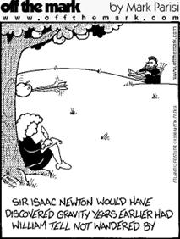

40

TIME: 1 Hour

ITEMS Formula & data sheet
Non-programmable calculator

NOTE:

1. Calculations must show clear working with answers stated to three significant figures.
2. Marks will be allocated for clear and logical setting out.
3. To help identify your answer, underline each answer.
4. State assumptions for open-ended types of questions.

1. A rider & bicycle has a combined mass of 87.5 kg which has a change of speed from 3.75 ms⁻¹ to 7.843 ms⁻¹. Calculate and state the gain or loss in kinetic energy.
(2 marks)
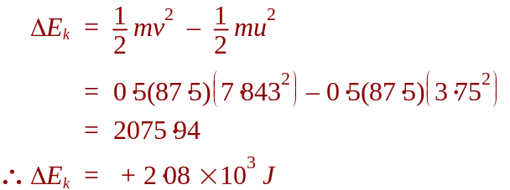

2. An electric incandescent light bulb uses 1250 J of electrical energy in 20.0 seconds.
Calculate the power rating of the bulb.
(2 marks)

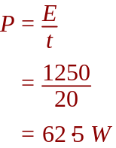

3. A stationary car of mass 1100 kg is hit from behind by a car of mass 1500 kg travelling north at a constant velocity of 20.0 ms⁻¹. The cars move off independently and the stationary car is pushed northward at a speed of 12.0 ms⁻¹.

Show your working to calculate the velocity of the 1500 kg car after the collision?
(3 marks)
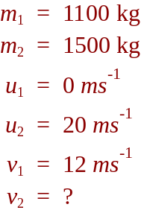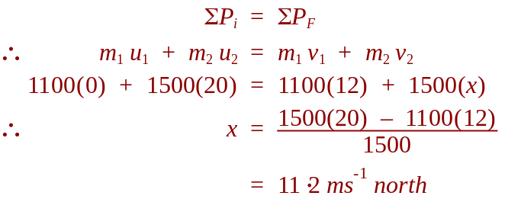

4 An alpine skier, with a mass of 85.0 kg, is skiing at 16.15 ms⁻¹ on firm snow. Suddenly the skier travels across some fresh snow and experiences a retarding force of 520 N for 1.25 seconds against his motion. After 1.25 s on fresh snow the skier again travels on firm snow.
What is the final speed of the skier when the skier leaves the fresh snow?
(4 marks)
NOTE: Two methods to solve the problem
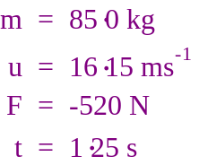 | 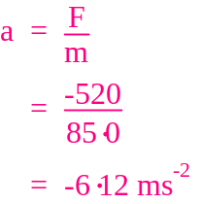 |   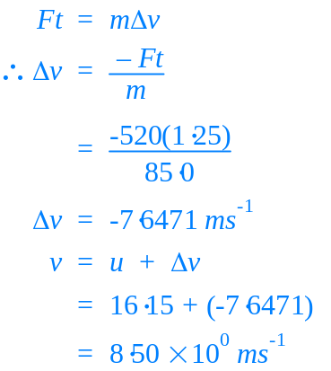
 | 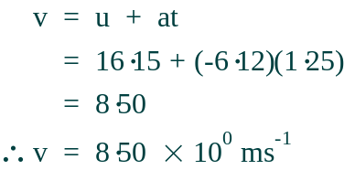

5. In the North of WA there is a design for a tidal power station. During each high tide the sea water storage area can hold 35.6 x 10¹² kg of the salt water. When the tide recedes (low tide) there is an average height difference of 2.12m. If this tidal power station is 20% efficient calculate the amount of energy the station produces from a single high tide.

(3 marks)

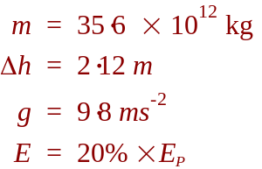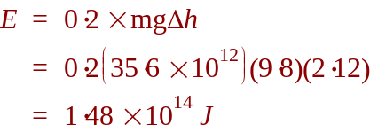

6. Mr Boughton, who has a mass of 85.5 kg, was a person not to waste time while on holiday in New Zealand and decided to do a bungee jump off an old wooden bridge. The bridge is 74.5 m above the ground. The bungee cord was 45.5 m long and he steps off the old wooden bridge and drops vertically.

a) Show your working and determine the time taken before the cord is likely to begin to stretch?
(2 marks)
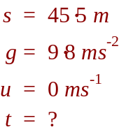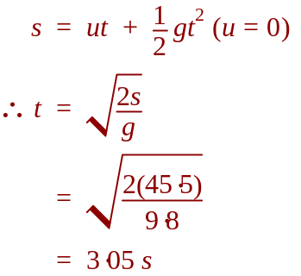

b) Show your working and calculate his velocity at the point when the cord should begin to stretch?
(2 marks)
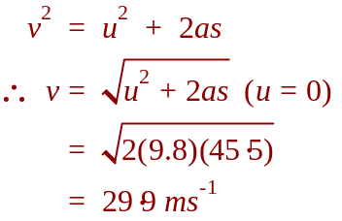

c) Priyam was on a working holiday in NZ and was employed by the Extreme Bungee Company. On her first day working on the bungee jump she failed to properly attach the end of the bungee cord to Mr Boughton’s feet. Show your working to determine his impact velocity.
(2 marks)

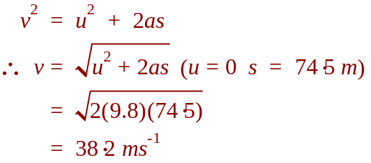

d) State 2 assumptions you have to make in order to arrive at your answer above.
(1 mark)
1. | No air resistance
2. | No retardation force from bungee cord
7. While on vacation Allison & Shana decide to ride the Roller Coaster of Terror. The roller coaster trolley, with only 2 passengers on board, has a total mass of 280 kg when in operation. At point C the speed of the loaded roller coaster trolley was measured as 10.0 ms⁻¹.
9.50 m
5.50 m
C
A
B
Roller coaster track

a) Show your working and calculate the total energy of the trolley at point C.
(2 marks)
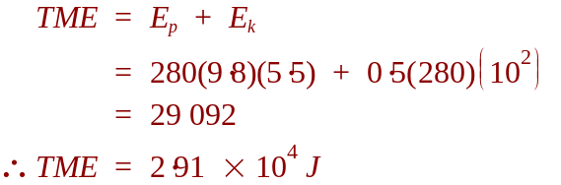

b) While the trolley is travelling from point A, through point B, to point C the associated friction causes a 20% loss of energy. Show your working and calculate the trolley’s speed at point A.
(4 marks)
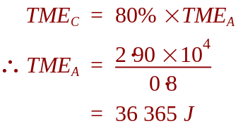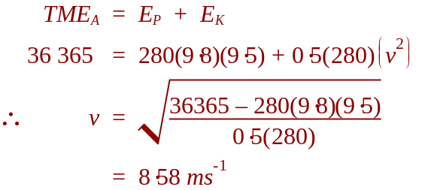

8. Andrew drives a car with a mass of 1833 kg up a 15.0º slope at a constant velocity of 8.50 ms⁻¹. The car experiences a constant friction of 350 N while travelling up the slope.

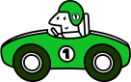
θ

a) Draw and label on the diagram to the right all the forces acting on the car.
(2 marks)

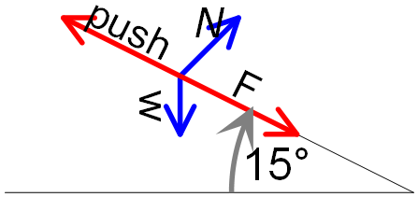

b) Calculate the power output of the car when it is travelling at a constant velocity up the slope.
(4 marks)
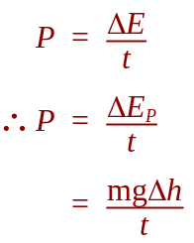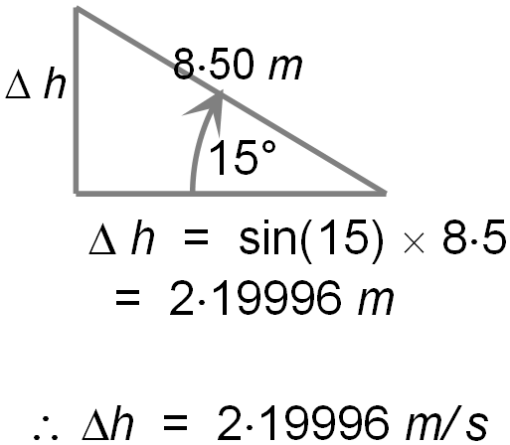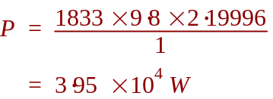

9. a) During a collision between a car and light truck, a passenger’s head strikes the unpadded dashboard with an average force of 56.0 N for 2.70 x 10 ⁻³ seconds. If a layer of foam padding was used within the dashboard the impact would have lasted for 5.80 x 10 ⁻² seconds. Calculate the average reaction force the padded dashboard would exert.
(3 marks)
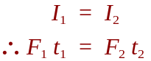

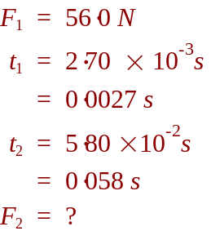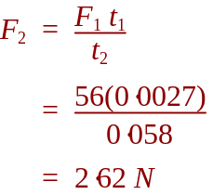

b) Explain, using physics terminologies, why car designers put crumple zones at the front of motor cars?
(2 mark)

Impulse must equal change in momentum 
Crumple zones increase t, decreasing F and reducing injury.

10. A car with a constant velocity of 12.0 ms⁻¹, collides with a solidly built concrete wall. During this collision the car applies a force of 8500 N and the concrete wall remains undamaged. What is the maximum force that the concrete wall could exert on the car?
(2 marks)

Using principals of Newtons third Law, the force applied my the car on the wall is the same, but in the opposite direction to the force applied by the wall on the car.

Therefore the wall applies 8500 N.

☺ CONGRATULATIONS: ☺
YOU HAVE COMPLETED THE 2nd Y11 PHYSICS TEST

